Project Report
On
literature review on synthesis and characterization of halide perovskites

Submitted by

SHIVANSH SHARMA
Department of Chemical Engineering
Birla Institute of Technology and Sciences, Pilani, Rajasthan
(Duration of project work: 30-05-2023 to 21-07-2023)

Under the guidance of

Dr. Biplab K. Patra
Scientist, Material Chemistry Department, CSIR IMMT



CSIR-Institute of Minerals & Materials Technology
Bhubaneswar-751013, Odisha, India
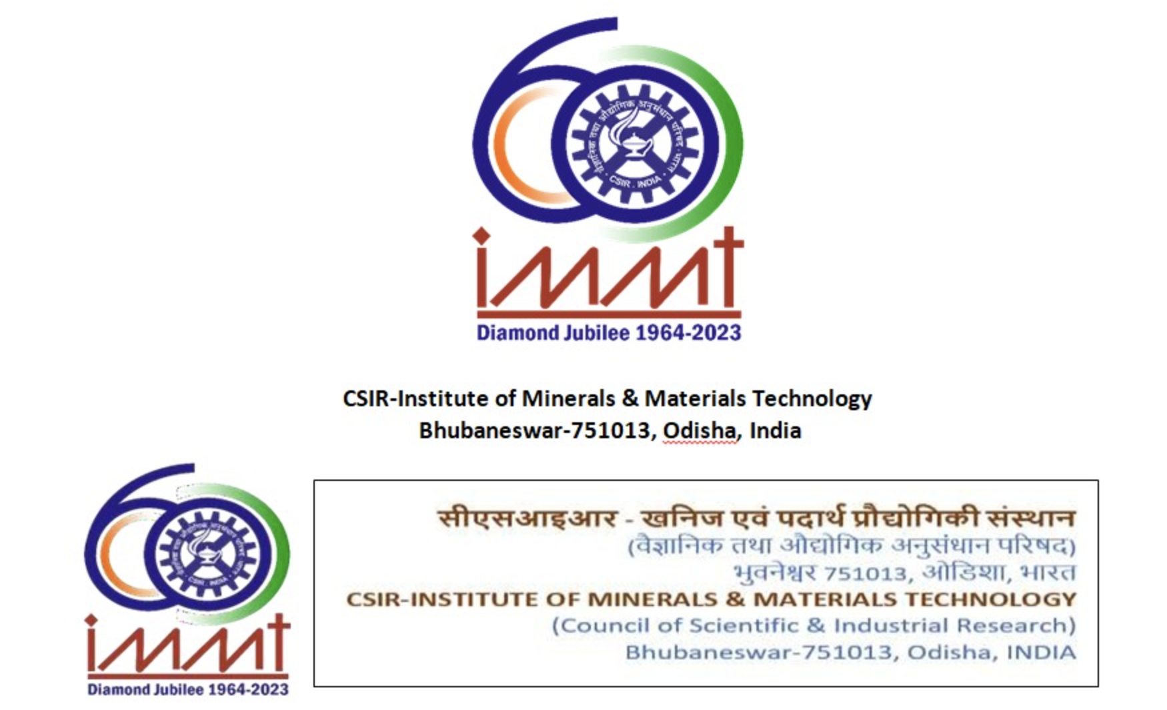

This is to certify that the work incorporated in the report entitled Literature Review on Synthesis and Characterization of Halide Perovskites is a record of research work carried out by SHIVANSH SHARMA under my guidance and supervision from 30-05-2023 to 21-07-2023 in Materials Chemistry Department of CSIR- IMMT.




Signature of the Student Signature of the Guide
Date: 17/07/23 Date: 21/07/23

Shivansh Sharma Dr. Biplab K Patra
B.E. Chemical Engineering Scientist
Birla Institute of Technology & Science, Pilani Materials Chemistry Department

Acknowledgement

I am thankful to Dr Ramanuj Narayan, the Director, CSIR-IMMT, Bhubaneswar, HRD head Dr. D. S Rao, and HRD department for providing me a platform to get research exposure and carry out a short term research project.
It is with a feeling of great pleasure that I would like to express my most sincere heartfelt gratitude to Dr. Biplab K Patra, Principal Scientist, Material Chemistry Department, CSIR-Institute of Minerals and Materials Technology, Bhubaneswar for suggesting the topic for my summer internship and for his ready and able guidance throughout the course of preparing the report. I thank you sir for your help, inspiration and blessings. I express my sincere thanks to Dr. Laxmidhar Beshra, Head of Material Chemistry Department for providing me the necessary facilities in the department to carry on with my project.
I am really fortunate that, I had the continuous support of Mr.Prabhanjan Pradhan and Mr. Jatin Mahato. Their guidance, constant encouragement and careful monitoring throughout the internship are great. I am also thankful to Swapneswar Bisoi and Bijo Benny for their kind cooperation and immense support throughout this internship.
Shivansh Sharma

Declaration

This is to certify that the work incorporated in the report entitled Literature Review on Synthesis and Characterization of Halide Perovskites is a record of research work carried out by me under the guidance and supervision of Biplab K. Patra from 30th may 2023 to 21st July 2023 in Materials Chemistry Department and the same cannot be either published or applied for an IP (Intellectual Property) without the consent of him.



Date: 17/07/23

Shivansh Sharma
B.E. Chemical Engineering
Birla Institute of Technology & Science, Pilani

Abstract

This literature review evaluates the synthesis, nucleation mechanisms, structural modifications, and characterization techniques associated with halide perovskites for optoelectronic applications. Lead halide perovskites (LHPs, ${\text{ABX}}_{3}$) possess exceptional optical and electronic properties- such as high light-harvesting efficiency, long carrier diffusion lengths, high charge carrier mobilities, and tunable bandgaps, rendering them valuable candidates for solar cells, light-emitting diodes (LEDs), and photodetectors. However, commercial viability remains constrained by ambient instability under moisture, heat, and light, alongside environmental and toxicity concerns related to lead. To address these challenges, alternative lead-free halide perovskites (LFHPs) utilizing homovalent (${\text{Sn}}^{2+}$, ${\text{Ge}}^{2+}$) and heterovalent (${\text{Bi}}^{3+}$, ${\text{Sb}}^{3+}$) metal cations, as well as structural variants like the ${\text{A}}_{3}{\text{B}}_{2}{\text{X}}_{9}$ family, are examined. The review analyzes thermodynamic nucleation kinetics comparing homogeneous and heterogeneous growth via classical LaMer crystallization theory and solubility/supersaturation dynamics. Additionally, synthesis methodologies including Vapor-Liquid-Solid (VLS) deposition, wet chemical growth, hot injection, and temperature-controlled precipitation are systematically evaluated for their control over nanocrystal morphology and monodispersity. Finally, primary characterization techniques, specifically X-ray Powder Diffraction (XRD), Scanning Electron Microscopy (SEM), UV-Vis Spectroscopy, and Energy-Dispersive X-ray Spectroscopy (EDAX) are detailed to highlight their role in elucidating the structural, morphological, and optical properties essential for developing stable, next-generation semiconductor devices.

